2020 Turkey Trot 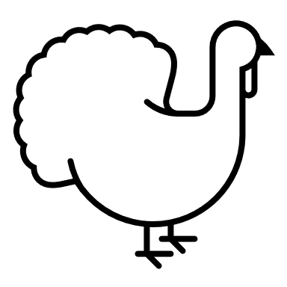

Length: 5K Walk/Run
Registration Time: 2:30pm
Race Begins: 3:00pm
Entry Fee: $15
Guess your time at the beginning! The walker/runner closest to their time will receive a free Turkey!
Route Info:
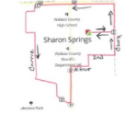
First Name:__________________ Last Name:_________________

Age on Race Day:____________________ Male Female

Email:_____________________________________________

Signature:__________________________________________

