**2020 Turkey Trot** 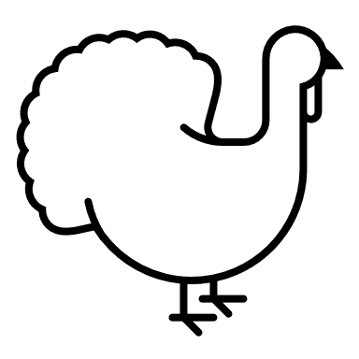

**Length: 5K Walk/Run**

**Registration Time: 2:30pm**

**Race Begins: 3:00pm**

**Entry Fee: $15**

**Guess your time at the beginning! The walker/runner closest to their time will receive a free Turkey!**

**Route Info:**

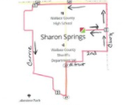

**First Name:__________________ Last Name:_________________**

**Age on Race Day:____________________ Male Female**

**Email:_____________________________________________**

**Signature:__________________________________________**